Date: 23/4/2024

**Name: Girish s Roll: AM.EN.U4AIE22044**

Lab Assignment - 1

**Signal Generation**

|  |
| --- |
| Course Outcome:  CO1: Familiarise the basic concepts of communication systems |

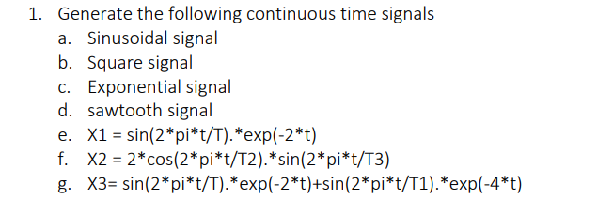

clear all;

f = 2;

T = 1/f;

t = 0:0.01:6;

%Sinusoidal signal

x1 = sin(2*pi*f*t);

subplot (4,2,1) ;

plot (t,x1);

title ('a. Sinusoidal Signal');

ylabel("x1(t) "), xlabel ("t");

%Square signal

x2=square(2*pi*t);

subplot(4,2,2) ;

plot(t,x2);

title('b. Square Signal');

%exponential signal

x3=exp(-2*t);

subplot(4,2, 3) ;

plot(t, x3) ;

title('c. Exponential Signal');

%Sawtooth signal

x4=sawtooth(2*pi*t);

subplot(4, 2, 4) ;

plot(t, x4);

title("d. Sawtooth Signal");

% X1 = sin(2*pi*t/T).*exp(-2*t)

x5 = sin(2*pi*t/T).*exp(-2*t);

subplot(4, 2, 5)

plot(t, x5);

title("e. X = sin(2*pi*t/T).*exp(-2*t)");

x6 = 2*cos(2*pi*t/T).*sin(2*pi*t/T);

subplot(4, 2, 6);

plot(t, x6);

title("f. X = 2*cos(2*pi*t/T).*sin(2*pi*t/T)")

x7 = sin(2*pi*t/T).*exp(-2*t)+sin(2*pi*t/T).*exp(-4*t);

subplot(4, 2, 7);

plot(t, x7);

title("g. X = sin(2*pi*t/T).*exp(-2*t)+sin(2*pi*t/T).*exp(-4*t)")

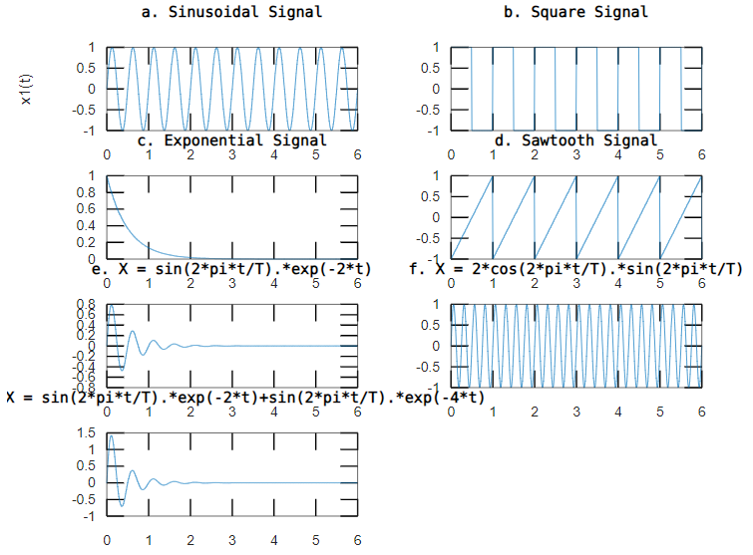

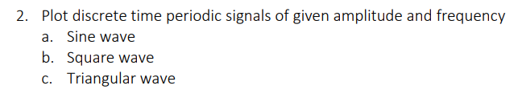

% Parameters

amplitude = 10;

frequency = 5;

t = 0:0.01:5/frequency;

% Sine wave

sine_wave = amplitude*sin(2 * pi * frequency * t);

% Square wave

square_wave = amplitude*square(2 * pi * frequency * t);

% Triangular wave

triangular_wave = amplitude*sawtooth(2 * pi * frequency * t, 0.5);

subplot(3,1,1);

plot(t, sine_wave);

title('a. Sine Wave');

xlabel('Time');

ylabel('Amplitude');

subplot(3,1,2);

plot(t, square_wave);

title('b. Square Wave');

xlabel('Time');

ylabel('Amplitude');

subplot(3,1,3);

plot(t, triangular_wave);

title('c. Triangular Wave');

xlabel('Time');

ylabel('Amplitude');

